 | Year 12 Specialist  TEST 3  Monday 1 July 2019  TIME: 45 minutes working  Classpads allowed  One page of notes  42 marks 6 Questions

Name:_______________________________

Teacher: ____________________________

Note: All part questions worth more than 2 marks require working to obtain full marks.

Q1 ( 3 & 3 = 6 marks)
- Solve for the following system of linear equations without using a classpad.

Q1 - continued
- Determine the values of such that such that the system has
- Infinite solutions
- No solutions

Q2 (2 & 3 = 5 marks)
If , determine

- (no need to simplify)

Q3 (2, 3 & 3 = 8 marks)
An object is initially at the origin with initial speed of and an acceleration given by
at time seconds.
Obtain an expression for the:
- Velocity at time .

- Position vector at time .

- Is the velocity ever perpendicular to the acceleration? Explain and if necessary solve for values (if any).

Q4 (3, 3, 3 & 3 = 12 marks)
Consider a cannon ball that is projected from the top of a building with speed at an angle to the surface of the roof. There is a constant cross wind of 3 metres per second acting against the ball and the acceleration due to gravity is down as shown in the diagram below. (Note- let the origin be at the top of the building on the edge)

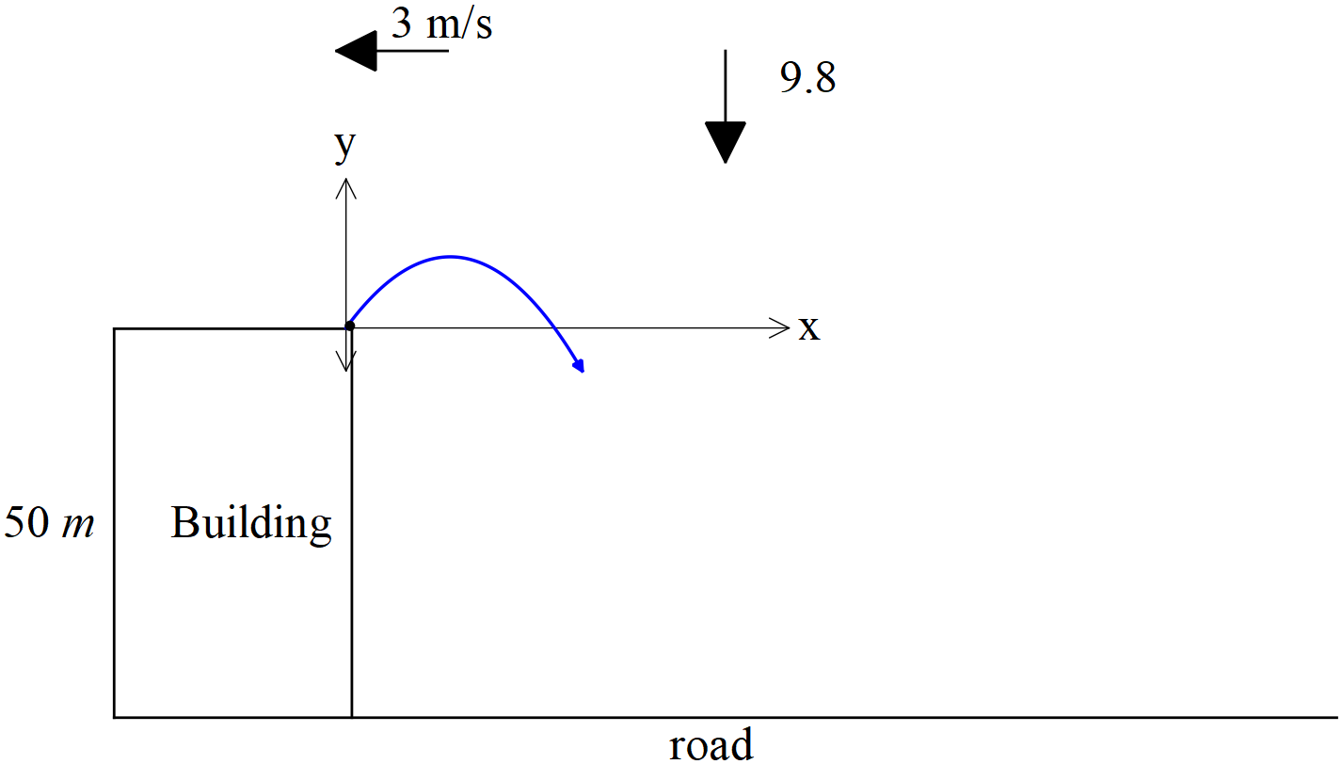

- Given that the acceleration is given by show using vector calculus that the velocity .

- Determine the cartesian equation of the path of the cannon ball in terms of . Show your working.

Q4 continued
- Given that a point on the cartesian path has been measured as metres and the initial speed of the ball from the cannon is 12 , determine the initial angle of the ball when projected into the air.

- If and and a cross wind of m/s as in the diagram on last page, determine how far from the foot of the building that the cannon ball lands on the road.

Q5 (2 & 5 = 7 marks)
Consider two rides at a circus, one is a merry go round and the other is a train on a straight line. Two twins decide to each try one of the two rides, Jane sits on the merry go round with a constant angular speed of radians/minute moving in a clockwise direction and radius 6 metres and Mia sits on a train moving at 3 metres/minute away from the merry go round. See the diagram below.

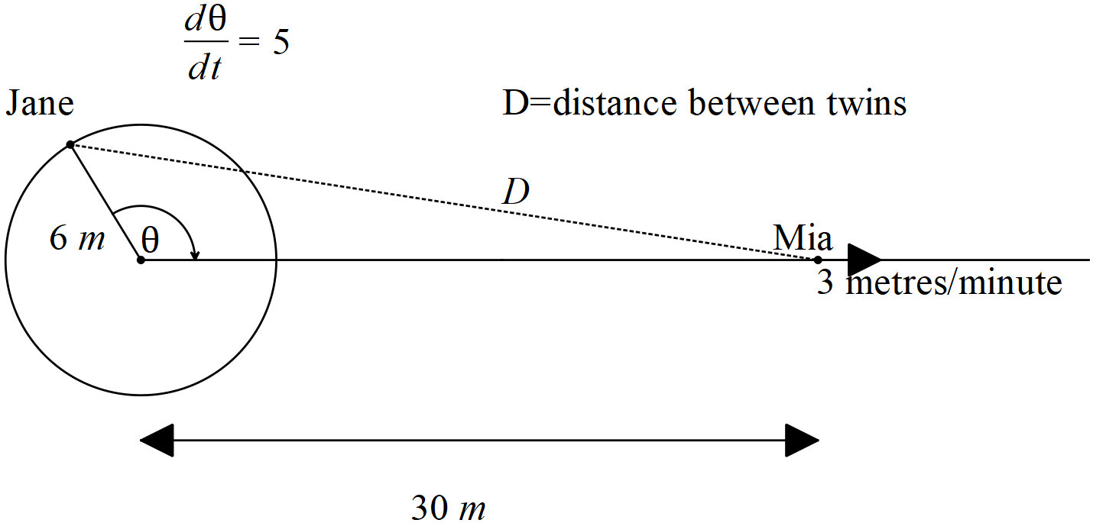

- Determine the distance between Jane and Mia when and the train is 30 metres from the centre of the merry go round.

- Determine the time rate of change of this distance at the point defined in (a) above. (metres/minute)

Q6 (4 marks)
Given that are functions of , show that

